2017 Mid term exam for C#

1. Choice problem: 1 points for each

( )1. What is a class? (a) a programming encapsulation that mimics real life objects. (b) a group of programmed code that is ~~not necessarily~~ related. (c) hardware and software of the computer. (d) ~~“~~**~~set”~~** ~~code that is not easy to update, but never needs changing.~~

( )2. Method overloading allows the programmer to: (a) create multiple methods with the same name but different arguments. (b) create methods with different variables of the same type. (c) create methods with the same parameters but different names. (d) None of the above.

( )3. Which of the following correctly declares and allocates an array of double values?

(a) double new A[15];

(b) double[ ] A = new double[15];

(c) double A = new double[25];

(d) All of the above.

( )4. The code within a **set** accessor of a property is executed when: (a) the **set** method is called. (b) a value is assigned to the property. (c) the client attempts to read the data. (d) None of the above.

( )5. What is an object? (a) a programming encapsulation that mimics real life objects. (b) a group of programmed code that is not necessarily related. (c) hardware and software of the computer. (d) “**set”** code that is not easy to update, but never needs changing. (f) a same variable can not be shared by several objects.

( )6. The statement (counter is declared as integer)

while ( ++counter >= 1)

counter % 2 ? couter-- : couter++”;

can not be rewritten as

1. while ( ++ counter >= 1 )

if (counter % 2) --counter;

else counter ++; SAME

1. while ( counter >= 1)

if (counter % 2) counter --;

else ++counter ;

++counter;

1. while ( counter >= 1){

if (counter % 2) --counter;

else counter ++;

counter++; }

1. do{ counter % 2 ? --counter : ++counter;

counter++; } while (counter >= 2);

1. while ( ++ counter >= 1 ) {

if (counter % 2) counter --;

else counter ++;} SAME

1. while ( ++ counter >= 1)

{counter % 2 ? couter-- : ++couter”;} SAME

( )7 In a switch structure (a) a break is required after each case (b) multiple actions do not need to be enclosed in braces (c) a default case is required (d) a break is required after the default case (e) at least one break is needed (f) condition in case statement must be numerical.

( )8. Which of the following is false about a function being passed an array ? (a) it knows the size of the array it was passed t (b) it is passed the address of the first element in the array t(c) it is able to modify the values stored in the array t(d) the array name (formal parameter) can be seen as a local variable t(e) the array name (formal parameter) cannot be the same as the actual parameter f(f) C# tried to save the memory of parameters if the array is passed.

( )9. The assignment operator (a) asserts that one variable is equal to another (b) places the values on the right into the variable on the left (c) can set the constant on the right equal to the constant on the left (d) can place the constant on the left into the variable on the right (e) makes an equivalence between the names of two variables (f) can change the value of constant

( )10 while loops and do loops differ in that (a) a do loop is terminated by a condition arising within the loop f(b) the number of times a while loop while cycle is known before the loop is entered f(c) a while is terminated by a condition arising within the loop f(d) the body of a do loop is always executed at least once t(e) the loop variable cannot be unchanged within a do loop

( )11 Which of the following are true ? (a) An else is associated with the if that has the same indentation as the else f(b) An else is associated with the if that is closest to the else, if that if is not surrounded by braces t(c) An else is associated with the if that is surrounded by braces and immediately precedes the else f(d) The body of an else is executed if the test expression in the corresponding if is true f(e) The body of an else is executed if the test expression following the else is true

( )12 A local automatic variable is created when which events have occurred ? (a) The program loads F(b) The program executesF (c) The variable is defined F(d) The variable is assigned a value F(e) Control is transferred to the function in which the variable is defined

( )13. A static member variable in a class (a) is duplicated within each object.F (b) does not really exist, in the sense of being defined. F (c) has only one copy for the entire class. T(d) is duplicated in each member function.F (e) Represents something about the class as a whole.

( )14. The **new** statement (a) is used to declare objects or variables. F(b) can create and initialize an object. T (c) return the memory of a class. F (d) returns some data values of an object or variable. F(e) withdraw an amount of memory for an object or variable. F

( )15. Which one is false? (a) Printed Circuit Board (PCB) is a hardware component that provides electrical connections between devices; T(b) The mainboard is the central PCB in a system devices such as processors and main memory are attached; T(c) graphics card contains a coprocessors that executes special-purpose instructions, like drawing graphs; T(d) Machine language is defined by the software corporation; t(e) machine language consists of streams of numbers (1s and 0s) that instruct computers how to perform elementary operations. T

( ) 16. The assignment operator (a) asserts that one variable is equal to another F(b) places the values of R-value into the memory of L-value T(c) makes an equivalence between the names of two variables F(d) will not return a value after its execution F(e) allows the L-value to be a constant variableF

( )17. In C-like language, a string variable (a) contains has a character with a numerical value of 0 (zero) at the end. (b) has a character count stored in memory along with it f(c) is terminated by the null character ‘\n’ f(d) must be manipulated one character at a time for input/outputF

II. Briefly answer the following questions: 9 points for each

1. Figure 1. is the process from writing a user’s code to execute it. Please (a). write why there are figures 400, 4000, 4100, and 4400 in Figure1; (b). write the corresponding actions, i.e., writing codes, compiling, loading and executing, you use in Visual studio for C#.



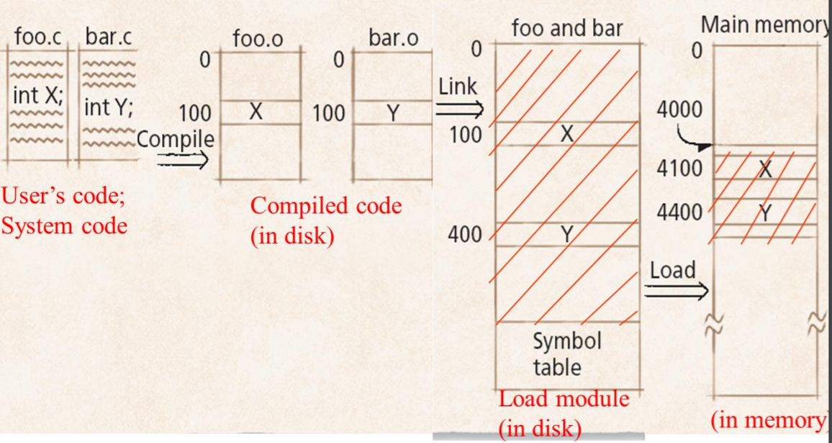



Figure.1

1. Please (a). write the results of the following statement; (b). rewrite it using while statement, and do while statement, respectively.

for ( i =1, k = 0; i < 10 && k < -4; i++, k--)

{k+= i; i= k-2; Console.WriteLine( "\n loop result are {0}, {1}", i, k ); }

1. For the following code, please explain (a). the meaning of decimal; (b). the meaning of Math.pow in the viewpoint of static definition; (c). the action of “\t”; d. the meaning of “{0:C}”.

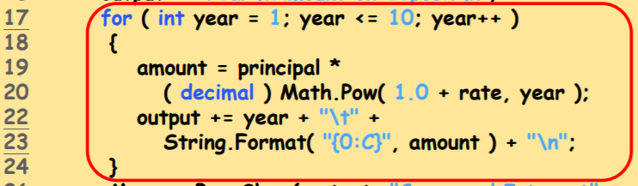



1. For the code,

int a = 3, b = 2; b = a+b;

we assume that i. variable a is in memory address 940, and variable b in 941; ii. the compiling process translates “b = a + b” in Figure 2.a; iii. the meaning of assembly code and related registers (CPU arithmetic components) in Figure 2. iv. The partial execution steps is shown in Figure 2.c.

|  |  |  |
| --- | --- | --- |
|  |  |  |
| Figure 2.a | Figure 2.b | Figure 2. c |

Please fill all the blanks in Figure 2.c. Note: Your answer style is step 1. ???; step 2.???, and so on.

1. For the codes in Figure 5. Please follow the execution steps and write the value count if its value is change (including the initialization) after executing the codes in Figure 5.a and 5(b). Your answer style is as follows:



in Figure 5.a. after line 8, count = ??; after line 9, count = ??; after line 14,

Note: the order of your answer should be the same as the order of the execution order the program.

|  |  |
| --- | --- |
| 1. Class test2{ 2. static void Main () {  1. int count;  1. count = 20; 2. add_C();  1. add_C();  1. }  1. private add_C() {  1. int count = 10;  1. count++;  1. } } | 1. Class test() { 2. int count =30 ;  1. static void Main () { 2. count = 20;  1. add_c();  1. sub_c();  1. }  1. public void add_c() {  1. count++; }  1. private void sub_c() {  1. int count = 8;  1. count--; 2. } } |
| Figure 5.a | Figure 5.b |

6. For the codes in Figure 6. Please draw the memory status for each variable, including formal and actual ones (a) just entering method f1() in Figure 6.a; (b) just before leaving method f2()the last code of the program in Figure 6.b, (c) after leaving method Calculate() in Figure 6.c .



|  |  |  |
| --- | --- | --- |
|  |  |  |
| Figure 6.a | Figure 6.b | Figure 6.c |

7. Please write a method in recursive function to compute (a) 5n, n >=0; (b) -3 + -2 + -1 + 0 + 1 + ….+n. You cannot write the method in while statement.



8. Please draw the memory status for the variables for the following statements:

* int b = 99;
* int[] b = {14, 13, 15};
* string s = “Good”;
* **int[][] b ={{11,12},{13,14,15}};**
* string[] s = {“Yes”, “No”};
* **String [] b1 = new String[ 2 ];**

9. For the codes in Figure 9, please draw the memory status after executing line 20 in the right part of Figure 9

|  |  |
| --- | --- |
|  |  |

Figure 9

10. For the codes in Figure 10, please draw the memory status after (a) executing line 102 in Figure 10.b; (b) executing line 102 in Figure 10.c;

|  |  |  |
| --- | --- | --- |
|  |  |  |
| Figure 10. a | Figure 10. b | Figure 10. c |

11. For the codes in Figure 11, please draw the memory status after executing line 30 but before line 31 in the right part of Figure 11

|  |  |
| --- | --- |
|  |  |

Figure 11

